Scanned by CamScanner

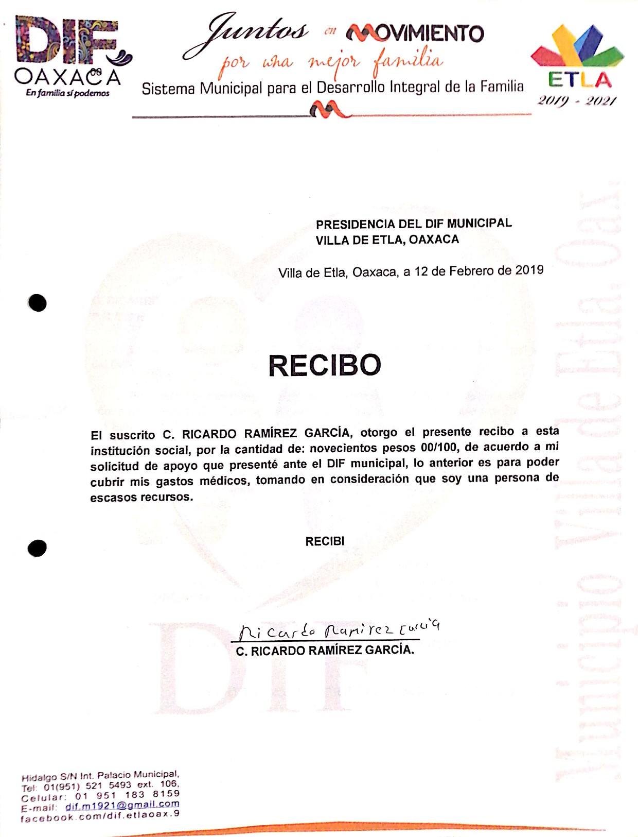
Scanned by CamScanner

Scanned by CamScanner

